**CP Club 365 Days Challenge**

**Programming language – C++**

**Problem Statement**

<https://www.codechef.com/problems/INCRIQ?tab=statement>

Git :- <https://github.com/Vedantbharad2603/CP_club_365_Days>

**Your Code**:

// 0x131Day of 0x365Days challenge

// VEDANT BHARAD

// 26-2-2023

#include <iostream>

using namespace std;

int main() {

    // your code goes here

    int x;

    cin>>x;

    if((x+7)>170)

        cout<<"Yes"<<endl;

    else

        cout<<"No"<<endl;

    return 0;

}

**Output (Screen Shot)**:

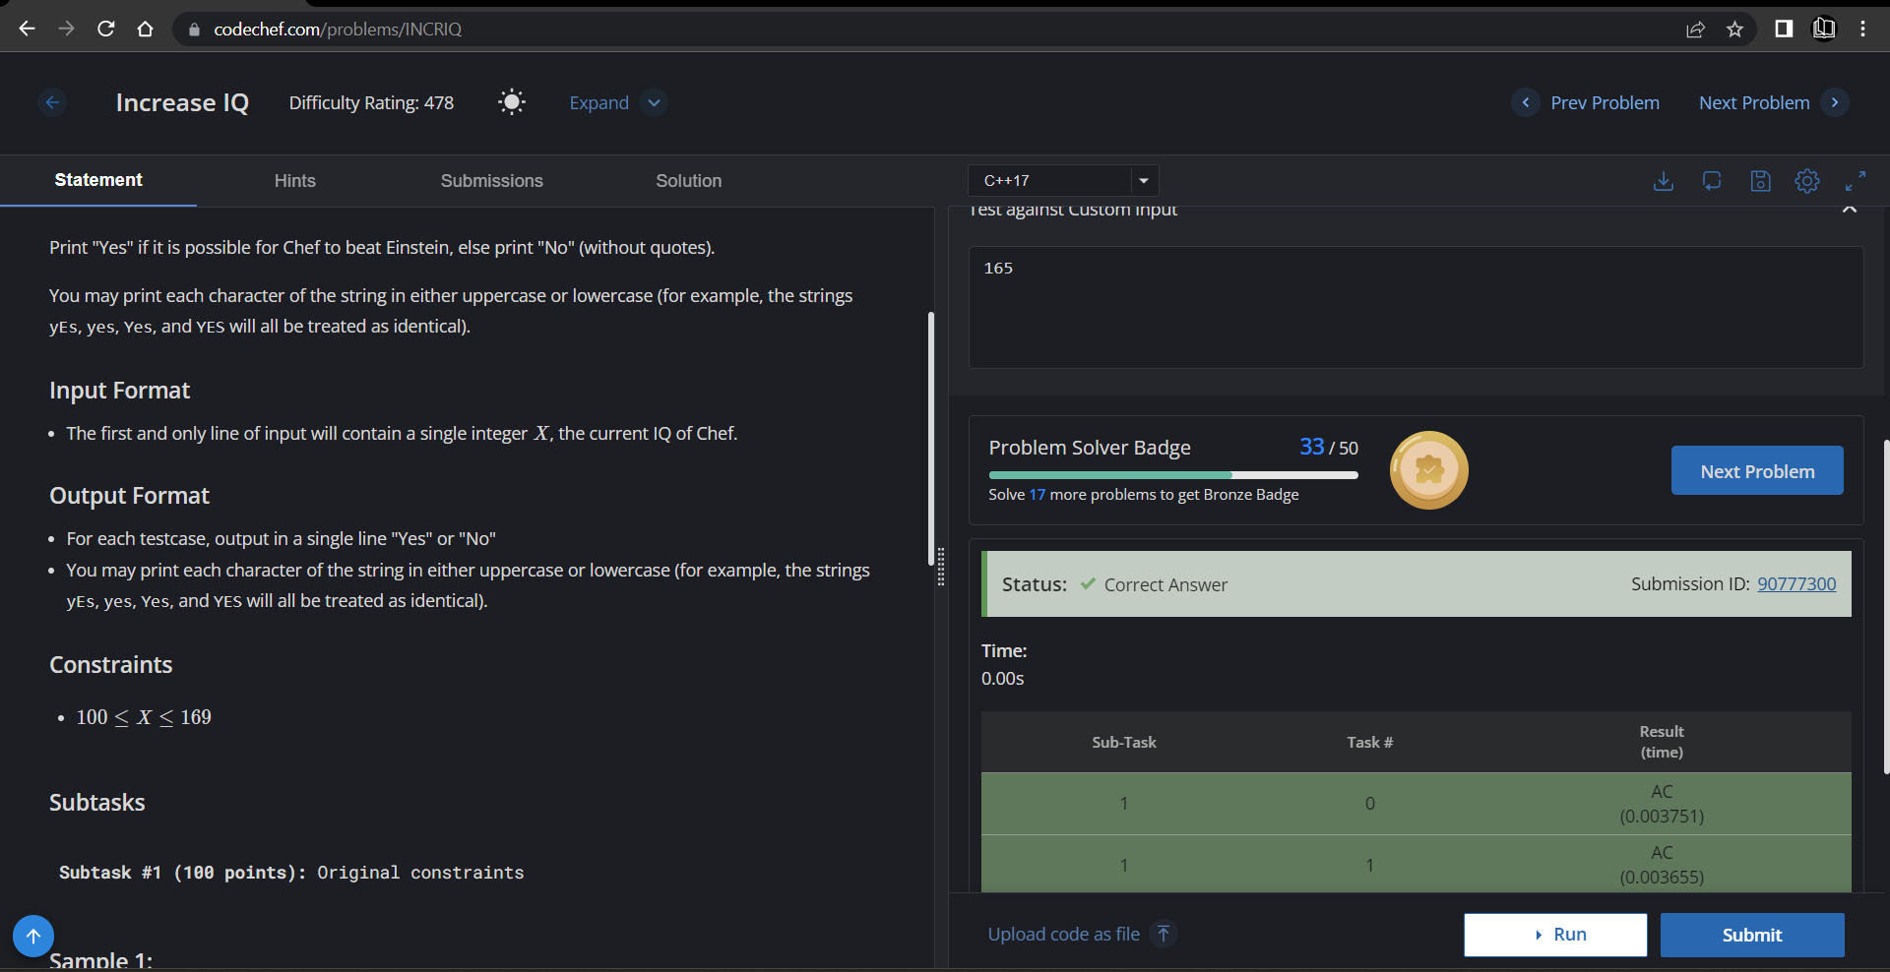

**Understanding about problem:**

* In this task I need to return “YES” if we add 7 in X and answer higher then 170 ,else return “NO”.

Note: If you can't understand the problem, feel free to contact us and we'll help you. Please don't copy and paste from anywhere.

ALL THE BEST

Team CP Club